**A Project Based Seminar Report**

**on**

**“VEHICLE INTERFACE MONITORING AND ACCIDENT CONTROL USING ARTIFICIAL INTELLIGENCE”**

Submitted to the

Savitribai Phule Pune University

In partial fulfilment for the award of the Degree of

Bachelor of Engineering

in

**Information Technology**

by

**ABUZAR TAMBOLI**

(T1751108)

Under the guidance of

**Mrs. AMITA JAJOO**



Department of Information Technology

D. Y. Patil College of Engineering

Akurdi, Maharashtra, India

**2019-2020**

CERTIFICATE

*This is to certify that the project based seminar report entitled* ***“****VEHICLE INTERFACE MONITORING AND ACCIDENT CONTROL USING ARTIFICIAL INTELLIGENCE****”*** *being submitted by ABUZAR TAMBOLI(T1751108****)*** *is a record of bonafide work carried out by him/her under the supervision and guidance of Mrs. AMITA JAJOO in partial fulfilment of the requirement for TE (Information Technology Engineering) – 2015 course of Savitribai Phule Pune University, Pune in the academic year 2019-2020.*

*Date:*

*Place:*

***Mrs. Amita Jajoo*** ***Dr. Preeti Patil***

*Guide Head of the Department*

*This project based seminar report has been examined by us as per the Savitribai Phule Pune University, Pune, requirements at D. Y. PATIL College of Engineering on . . . . . . . . . . . . . .*

*(Name & Signature) (Name & Signature)*

*Internal Examiner External Examiner*

ABSTRACT

*With the increase in demand for smart intelligent devices, integration of smart systems in automobiles is inevitable and certainly has gained large attention in recent times. To develop the intelligent smart systems, installing vehicle sensors and processing data from them is the key fundamental step. This paper provides an overview of how to capture certain critical vehicle data from various sensors and process the data which can later be processed for intelligent systems development and to display the relevant information for the rider.*

***Key Words:*** *Informatics, Infotainment, Smart Vehicle, GPS, Odometer, Speedometer, Data Logging, Dashboard.*

**CONTENTS**

|  |  |  |
| --- | --- | --- |
| Sr No. | Chapters | Page No. |
| 1. | Introduction | 5 |
| 2. | Motivation | 7 |
| 3. | Aim | 8 |
| 4. | Objective | 9 |
| 5. | Literature Review | 10 |
| 6. | Proposed System | 14 |
| 7. | Implementation(Digital Interface) | 18 |
| 8. | Result | 24 |
| 9. | Conclusion | 25 |
| 10. | Reference | 26 |

INTRODUCTION

In the modern world, automobiles take a great part in the development since it plays one of the major keys in daily life. Two-wheelers play a very important role because it saves the time of the traveller by reaching the target place faster. Two-wheelers, the mode of transport most Indians use, continues to be the most vulnerable to accidents.

The latest data released by the home ministry has revealed that 21% of the road death victims in 2015 in the country were riding two-wheelers. Estimates suggest that over 60% of the country's motor vehicles are two-wheelers. The majority (77%) of the victims in India were in the age group 18-44 years. Accident rate among males (83%) was higher than that among females (17%). Geared vehicles (81%) were more commonly involved than those without gears.

One of the most important safety rules to be followed while riding a motorcycle is wearing a helmet. And it is necessary for both the riders to wear helmets as in the case of an accident the driver, as well as the pillion is at equal risks of injury. The speed of the vehicle cannot be controlled in the situation of an accident. But safety factors can be increased to save lives.

Table 1: Statistics of Accidents

|  |  |  |  |
| --- | --- | --- | --- |
| **S.NO** | **DURING THE YEAR** | **REASON FOR THE ACCIDENT** | **%OF ACCIDENTS** |
| 1. | 2002-2008 | Forgetting to lift side-stand | 36% |
| 2. | 2002-2008 | Does not maintain speed limit | 38% |
| 3. | 2002-2008 | Does not obey traffic rules | 22% |
| 4. | 2002-2008 | Other problems | 04% |

Another simple thing people forget is uplifting the side stand of the motorcycle while riding. 36% accidents in India are caused due to this mistake. The main reason for this is the rush that people make while riding a motorcycle. While the two-wheelers are concerned accidents occur due to riding the vehicle at a high speed, ignoring to wear helmets, not maintaining the speed limit and forgetting to lift the side stand causes large no. accidents in rural areas as well as partly in urban areas too.

Because all the other sources of accidents have preventive measures, but accidents due to side stand do not have a proper preventive measure.

In order to reduce accidents due to carelessness in lifting the side-stand, many advanced measures have been introduced like ECU; the modern ECU contains a 32 bit and 40 MHz processor. It will be as fast as a PC's microprocessor.

The ECU decides timing and functioning of the engine and its parts. This plays its role in the dashboard, this indicates the gear shifting, side stand, to wear helmet in digital display E.g., Hero Honda’s Karizma ZMR.

But people ignore those indicators and safety rules. So for safeguard, many mechanical projects have been found to retrieve the side stand automatically.

With the advent of electric vehicles and owing to its simplistic design and lesser number of parts one can collect large amounts of data from the vehicle and use it for further research. With cloud connectivity, this data can be transmitted at real time and this paves way for an entirely new era in the transportation sector leading to intelligent connected transportation systems. Automotive grade Linux OS platform is an upcoming product whose development is completely open sourced and many automobile giants are already adopting this OS which can be used as base to develop informatics and infotainment systems and other applications based on the data. This report presents an effort on how we can combine automobile, data processing and cloud connectivity technologies which are fundamental in establishing a connected vehicle system.

Fundamental sensors like Speedometer, GPS and Accelerometer and gyro are used to develop the module using Raspberry Pi, the data from which is logged onto a database file and this information is transmitted via Wi-Fi and further GUI is developed to display ride metrics information onto a dashboard as shown below.

MOTIVATION

The current automobile industry is struggling with the issue of lack of information about the performance of product and its sub systems during its usage, which can later be used for future product development or improving the current product or sub systems.

This is mainly due to the fact that the collection of data from sub systems of gasoline vehicles is hectic and processing such large chunks of data is not possible.

With the advent of AI vehicles and owing to its simplistic design and lesser number of parts one can collect large amounts of data from the vehicle and use it for further research.

With cloud connectivity, this data can be transmitted at real time and this paves way for an entirely new era in the transportation sector leading to intelligent connected transportation systems.

AIM

The aim of this project is to provide a digital interface and safety measures for the motorcycle using Artificial Intelligence.

The project also aims at:

* **Rider’s Safety:** Detecting the side stand by using side stand alarm and indicators.
* **Digital Speedometer:** Instead of the analog speedometer we see in today’s two wheeler vehicles, a digital speedometer will be provided in the interface.
* **Speed Barrier:** This speed barrier will trigger if the vehicle is in a crowded place.

OBJECTIVE

The prime objective of this project is to develop a module which can collect data from vehicle sensors like speed, GPS information and motion tracking using accelerometer and gyro sensor and log the data onto a database file and is to make a system, which is embedded on a bike. This. The information collected is used to display ride metrics information onto a display dashboard on the vehicle.

Different sensors are used for better safety of the motorcyclist. Bikes can only be started when the motorcyclist removes the side stand. Whenever the sensor detects that the side stand if not removed, it switches ON an alarm. A speed sensor provides another safety. When the bike starts, it continuously checks the speed of the bike and warns the motorcyclist by giving a message and switching ON an alarm, when speed crosses the limit.

A rider can access the digital dashboard on the vehicle which will display the current speed, trip distance, travel time, GPS location status and lean angles of the vehicle. The dashboard UI interface can be changed as per the requirement and the can be accessible remotely by anyone who has the required credentials to the web server.

Once the ride is finished, the rider can visualize the riding information by gaining access to the web server which will display variations of speed vs time, paths travelled and can also track his motion.

LITERATURE REVIEW

|  |  |  |  |  |
| --- | --- | --- | --- | --- |
| Sr. No. | Name | Author | Year of  Publication | Description |
| 1. | Next generation intelligent connected E-scooter. | Mr. Kristina Flüchter, Mr. Matt Jones and Mr. Magnus Feuer.  Collaboration summit, at San Francisco, California | 2016 | The report on  Implementing the connected e-bike: challenges and requirements of an IoT application for urban transportation by Kristina Flüchter demonstrates how connecting physical systems like E-bike to virtual world is creating interest among users and the challenges and technological restrictions concerning the completeness of collected data from vehicle sensors which  are to be addressed. |
| 2. | AI Based Autonomous Bike | Rejwan Bin Sulaiman,  University of  Bedfordshire | 2018 | The conversion of normal conventional bikes into the autonomous Bike (Smart E-Bike), problems associated with it, objectives, requirements and the  expected outcome of this step. It will also cover the standards and give the critical  comparison between  traditional and E-bikes.  AI based bikes will cause a huge change in people’s life, research and analyse the various impacts on society, legal and ethical challenges. |
| 3. | Smart Bike System to make the City even Smarter. | Monika Rani and O. P. Vyas Department of Information Technology, Indian Institute of Information Technology, Allahabad | 2017 | Efficient bike sharing capable of not only sharing bikes also provides information regarding the availability of bikes per station, route business, time/day-wise bike schedule. The embedded sensors are able to opportunistically communicate through wireless communication with stations when available, providing real-time data about tours/minutes, speed, effort, rhythm, etc. We have been based on our study analysis data to predict regarding the bike's available at stations, bike schedule, a location of the nearest hub where a bike is available etc., reduce the user |
| 4. | Smart e-bike monitoring system: Real-time open source and open hardware GPS assistance and sensor data for electrically-assisted bicycles | [Chris Kiefer](https://www.researchgate.net/profile/Chris_Kiefer3),  [University of Sussex](https://www.researchgate.net/institution/University_of_Sussex).  [Frauke Behrendt](https://www.researchgate.net/profile/Frauke_Behrendt)  [University of Brighton](https://www.researchgate.net/institution/University_of_Brighton). | 2016 | The smart e-bike monitoring system (SEMS) is a platform for the real-time acquisition of usage data from electrically-assisted bikes (also called pedelecs or e-bikes). It is autonomous (runs off the bike battery), replicable (open source and open hardware), scalable (different fleet sizes) and modular (sensors can be added), so it can be used for further research and development. The system monitors location (global positioning system), rider control data (level of assistance) and other custom sensor input in real time. |

PROPOSED SYSTEM

In this report, we have proposed an Informatics system for an E-Bike which logs the riding data onto a web server and designed an Infotainment system which displays the riding

information on any device which can run a web page. Given that the data collection and information display are independent of each other one has the advantage of

designing the web page to display raid information in his own way. In future one connect battery information to the module to check for battery status and other vital sensors to

the module and can interpret the data remotely. The Wi-Fi based communication can be replaced by the mobile internet from the service provider to maximize the network range.

Prima facie, it's a little difficult to interface directly with your digital speedo. Why? Unscrew that speedo and go down to its mother circuit - you'll see that the core parts of the circuit are obscured by a big black blob.

But, if you're trying to build a data collection system for your motorcycle, or, simply trying to reprogram your display, it might just make sense to build a whole new display. It's not terribly difficult. Here's how I would go about it:

**Requirement Set**: Decide what all it is that you want to display. Speed alone? Nah, you'd also want to capture the fuel level. Indicators? Headlights? Check and check. What else? I'd love to add a Lean indicator to my bike too. I'd also love to add a music sync with my phone, and Google Maps...the list is ende

**1. LCD:** Get a good quality LCD - you'll find a large variety of designs on Aliexpress. Note that most LCDs tend to degrade in quality, so you'd not really want to use the regular JHD12864E or the 16x2 that's found in most electronics shops (though it could be a good starting point)

**2. Processor:** I am biased towards the Arduino, and I've used an Arduino Mega in the past to make the rudiments of a speedo. You mention that you are experts in electronics, so I am guessing you are set there.

**3. Speed Measurement:** There is a hall sensor next to the front brake disc/drum. Isolate the two leads, connect these with your Arduino/any other microcontroller. A hall sensor is a magnet which fires a pulse every time a moving magnetic bolt (on your spokes somewhere) passes it by. Multiply that with the circumference of the bolt's radius and you get distance traversed per second.

When the engine turns over, the driveshaft turns to make the wheels spin round.

The speedometer cable, powered by the driveshaft, turns as well.

The cable spins a magnet around at the same speed inside the speed cup. The magnet rotates continually in the same direction (in this case, counter-clockwise).

The spinning magnet creates eddy currents in the speed cup.

The eddy currents make the speed cup rotate counter-clockwise as well in an attempt to catch up with the magnet. Remember that the magnet and the speed cup are not joined together in any way—there's air in between them.The hair spring tightens, restraining the speed cup so it can turn only a little way.

As the speed cup turns, it turns the pointer up the dial, indicating the bike's speed.

BASIC SENSOR WORKING

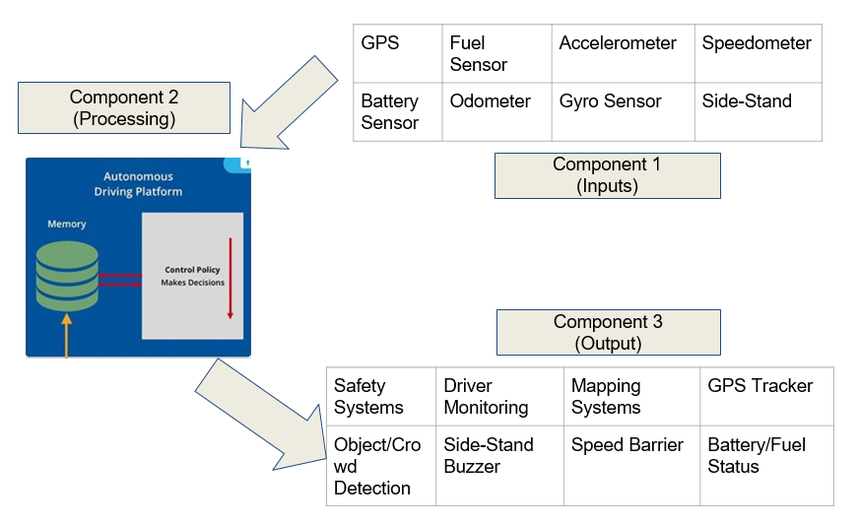

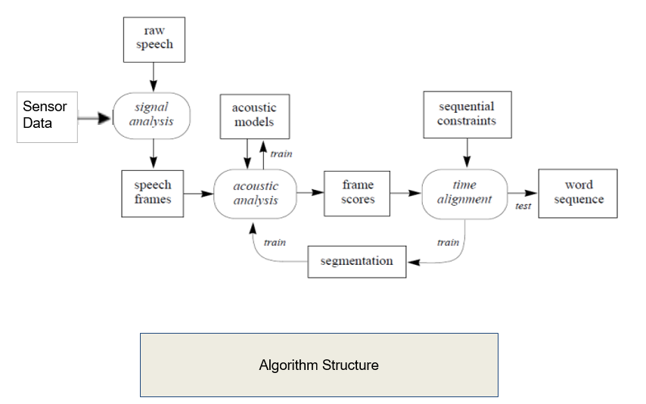

HISTORY OF BIKE INTERFACES

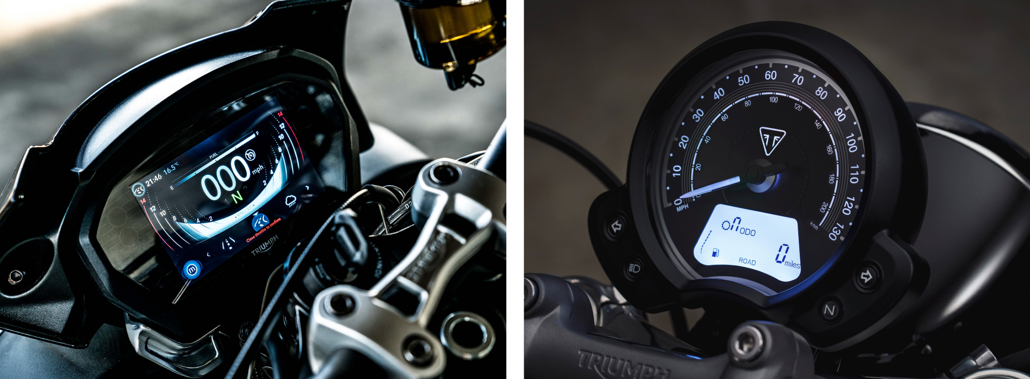

The last two years has seen a sea change in motorcycle instrument clusters. The interface has moved from traditional dials and LCD displays to TFT screens as seen in cars. This has allowed bike makers and designers to utilise every pixel, colour range and motion possibility to the maximum and going by current trends they are.

But with the freedom to display anything on this relatively small high definition screen, comes the issue of displaying too much information.

This ‘features’ tendency as we call it is a common trend in automotive interfaces which is unfortunately creeping into motorcycles as well. With motorcycle manufacturers making the same mistakes as car manufacturers, no one seems brave enough to step away from the standard conventions.

There is a tendency towards excess without really understanding what riders want to see — without the risk of adverse distraction. Also we see that manufacturers are not considering the opportunities offered by the contextual understanding afforded by the connected vehicles of today — which can make riding safer.

This thought piece speaks about this issue of excess and brings the focus back to the needs of the rider and an understanding of context — in defining the best possible user experience for a motorcycle’s interface.

Most importantly this is written by bikers — for bikers and the motorcycle industry in general. It is about bringing the passion, beauty and experience of the engineering and styling involved in the physical artefact that is the motorcycle — into the digital experience. We really hope that it delivers a set of guidelines and a point of view that will help the industry veer away from ‘features’ and start a positive dialogue.

**OUR FOCUS**

# Reducing clutter, increasing contextuality

•A DIGITAL INTERFACE is the medium through which humans interact with computers. Interfaces represent an amalgamation of visual, auditory, and functional components that people see, hear, touch, or talk to as they interact with computers (digital devices).

• In Bikes, information can include fuel amount, engine temperature, altitude, cut off fuel, turn off ignition, turn on headlight, turn on taillight, battery status, engine RPM and GPS.

# 

The seven dialogue principles of the interface are:

* Suitability for the task: the dialogue is suitable for a task when it supports the user in the effective and efficient completion of the task.
* Self-descriptiveness: the dialogue is self-descriptive when each dialogue step is immediately comprehensible through feedback from the system or is explained to the user on request.
* Controllability: the dialogue is controllable when the user is able to initiate and control the direction and pace of the interaction until the point at which the goal has been met.
* Conformity with user expectations: the dialogue conforms with user expectations when it is consistent and corresponds to the user characteristics, such as task knowledge, education, experience, and to commonly accepted conventions.
* Error tolerance: the dialogue is error tolerant if despite evident errors in input, the intended result may be achieved with either no or minimal action by the user.
* Suitability for individualization: the dialogue is capable of individualization when the interface software can be modified to suit the task needs, individual preferences, and skills of the user.
* Suitability for learning: the dialogue is suitable for learning when it supports and guides the user in learning to use the system.

Functionalities

* By connecting the interface with the speedometer sensor,

we can display the speed of the vehicle digitally(user friendly

mechanism).

* GPS tracking: The device fits into the vehicle and captures the GPS location information.
* The tracking server has three responsibilities: Receiving data from the GPS tracking unit securely storing it, and serving this information on demand to the user.
* A tracker may be placed on a vehicle to follow the vehicle's movements.

RESULT

With the monitoring system in place the vehicle is made to take some rides while the monitoring module is set to record and display concurrently the ride metrics information.

The collected data is later analyzed by accessing the data via web server. As the data from all sensors are logged concurrently one can check how fast the vehicle is moving at what place and how the vehicle is oriented at that instant at a place. The collective results of a ride.

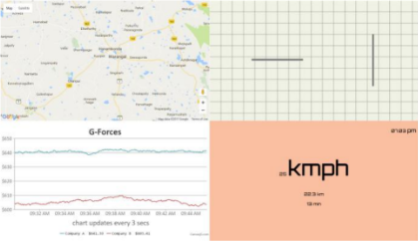

CONCLUSIONS

* In this study, we have proposed an Informatics system for an E-Bike which displays the riding information on the screen
* Major accidents can be avoided which makes this project a life saving mechanism.
* To develop the intelligent smart systems, installing vehicle sensors and processing data from them is the key fundamental step.
* There is a vast scope for research in this field as just the indication is not enough to ensure the safety of the rider since most of the time these warnings are ignored.

REFERENCES

1] von Watzdorf, S., and Michahelles, F. 2010. Accuracy of positioning data on smartphones. In LocWeb 2010 Proceedings (Tokyo, Japan, November 29, 2010).

2] Gusikhin, O., Rychtyckyj, N. & Filev, D. Knowl Inf Syst (2007) 12: 147.

doi:10.1007/s10115-006-0063-1.

3] "The Linux Foundation" YouTube. YouTube, 29 April 2013. Web. 29 January 2017.

4] Kristina, F., (2014), Implementing the connected e-bike: challenges and requirements of an IoT application for urban transportation,doi:10.4108/icst.urbiot.2014.257191.

5] "Why Connectedness Will Go beyond Mobile Devices & Apps?" Ather Energy. Ed. Tavleen.

N.p., 19 May 2016. Web. 04 Feb. 2017. [6] Shovic, John C. "Connecting an IOT Device to a Cloud Server - IOTPulse." Raspberry Pi IoT Projects (2016): 147-86. Web.

6] Philippe Garrigues, Environmental Science and Pollution Research Journal No. 11356, ISSN No. 1614-7499.

7] Rajeev Singh, Smart bike helmet & accidental prevention systems, Internation Journal for Electrocomputational World Knowledge Interface Vol. 4 Issue 2 Jan 2016, ISSN No. 2249-541X.

8] Salunke Vishwas, Modification of Exhaust System of Two wheeler for Emission Control, International Journal of Engineering Research & Technology (IJERT) ISSN: 2278-0181 Vol. 3 Issue 6, June - 2014

9] Sanjeev N K, Bike Side Stand Unfolded Ride Lock Link, International Journal of Advanced Research In Engineering Technology & Services, September 2013.

10] Thakur Mukesh, Reduction of Pollutant Emission from Two-wheeler Automobiles using Nano-particle as a Catalyst, Research Journal of Engineering Sciences Vol. 1(3), 32-37, Sept. (2012).